Skin Lesion Analysis towards melanoma detection
(Capstone Project)

A REPORT
Submitted by
Shah Jitesh P.
(Student-ID)

Abstract
Skin Lesion Analysis towards melanoma detection
Capstone Project by Jitesh. P. Shah
at
S.P Jain School of Global Management, April 2017

Skin cancer is a major health problem, with over 5 million newly diagnosed cases each year in the united states. Melanoma is one the deadliest form of skin cancer, which is responsible for 9,000 deaths each year. This project aims at detecting the cancer and classifying it whether it is a malignant or benign. We take Images of the cancer infected skin and classifying those images into malignant and benign. The images were taken from the International Skin Imaging Collaboration(ISIC) archive. We have used neural network, a machine learning algorithm for the classification task. We empirically evaluate different models of neural network by changing specific hyperparameters. We are more focusing on the convolutional neural network, which works very effectively on the Image classification task. We have 2000 training, 600 testing and 150 validation images available.

Table of Contents

Abstract i
Table of Contents ii
List of Tables vi
List of Figures vii
Abbreviations viii
1 Introduction 1
1.1 Introduction to the Problem 1
1.2 Motivation for the Work 3
1.3 Objectives and Scope of the Work 3
1.3.1 Objective of work 3
1.3.2 Scope of the Work 3
2 Background Theory 5
2.1 Basics of neural network 5
2.1.1 Perceptron 5
2.1.2 The architecture of neural network 6
2.2 Basic of Convolutional Neural Networks 6
2.2.1 Structure 6
2.2.1.1 First layer 6
2.2.1.2 Going deeper through network 8
2.2.1.3 Fully connected layer 9
2.2.1.4 Training 10
2.2.1.5 Testing 13
3 Proposed Work 14
3.1 Architecture of Proposed Work 14
3.1.1 Image Acquisition 15
3.1.2 Image Pre-processing 15
3.1.3 Model Building 17
3.1.4 Model Evaluation 22
4 Conclusions 23
References 24

List of Tables
Table 1 Full Simplified Network Architecture 17

List of Figures

Figure 1 Process of Cancer Detection 2
Figure 2 Perceptron 5
Figure 3 Basic architecture of neural network 6
Figure 4 Activation Map 8
Figure 5 LeNet 10
Figure 6 Minimizing Loss 12
Figure 7 Optimization Problem 13
Figure 8 Block Diagram of Proposed work 14
Figure 9 Augmented Image samples 15
Figure 10 Input Image 17
Figure 11 Conv 1 18
Figure 12 Max Pooling Layer1 19
Figure 13 Convolution layer 2 20
Figure 14 Max Pooling layer 2 21
Figure 15 Convolutional layer 3 22

Abbreviations

Introduction
This chapter presents the brief introduction of project work. This chapter also describes the primary objective and scope of the research work.

Introduction to the Problem
Melanoma is one of the deadliest type of cancer. Melanoma is the cancer that starts in the melanocytes. Melanoma can develop anywhere in the skin. Melanoma tumors are generally brown or black. But some of the melanomas can also appear in the pink, tan or white. Melanomas can develop anywhere on the skin. They are more likely to target or start on the chest and back in men and legs in women [1].
This article attempts to apply concepts of Machine Learning and Computer Vision to solve the problem of detection and classification of Melanoma skin cancer. The main aspect of the project is to classify the cancer based on images those contain certain features, the cancer lesion holds. The machine learning techniques such as Neural network, K-means Clustering, support vector machine can be given effective solution in the detection and classification task, for example K-means clustering clusters the infected and non-infected region in the different clusters, so that we can effectively classify the skin cancer.
Deep neural networks are one the most successful algorithms in the machine learning algorithms. They have strong capability to solve the complex problem such as Image recognition, Speech processing, Image localization etc. Due to non-linear behavior of the algorithms it will successfully applied on images also.
We briefly present our approach to solving the problem of detection and classification of melanoma skin cancer. We collected images of the skin lesion from the International Skin Imaging Collaboration(ISIC) archive which held competition for detection and classification of melanoma skin cancer [2]. Since the color type of the images are different so we segmented the cancer lesion from the skin using Image thresholding technique. After segmentation of diseased portion from image, we fed the images to neural network along with labels.
Initially, we were experimenting our data on the simple three-layer neural network, with the sigmoid function, for baby stepping the whole process. We were also experimenting our work by applying different cost optimization such as Gradient decent, Adam, RMS prop etc. We were also applying different activation functions such as relu and tanh. We have also experimented convolutional neural network with deep layers for better performance on the validation data. Since we have only little amount of data to feed into Convolutional neural networks, we used data augmentation to increase the size of our training data, so that it fits well on the validation data. The process of disease detection and classification is shown in the Figure 1.
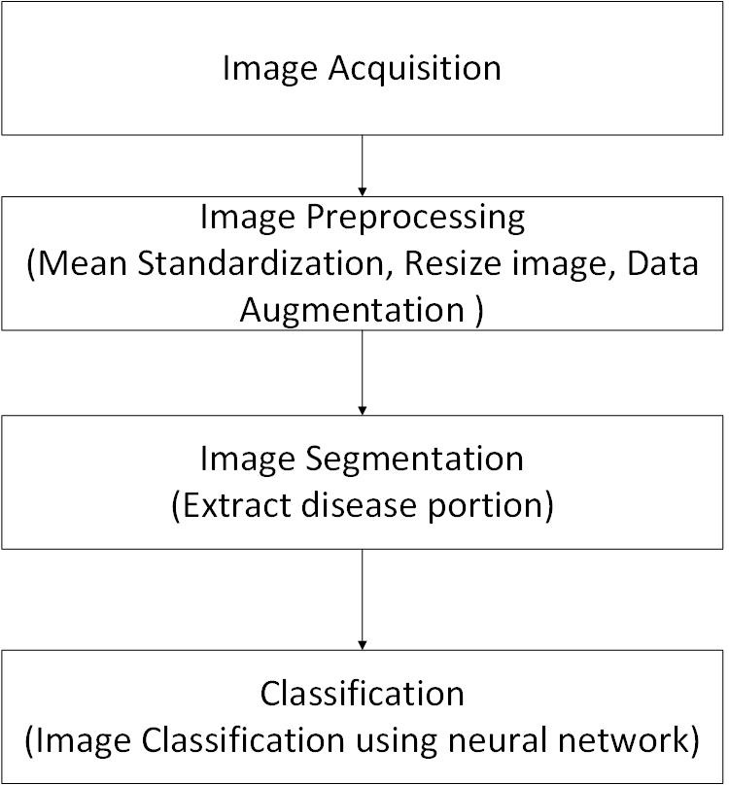
Figure 1 Process of Cancer Detection

Motivation for the Work
Cancer of the skin is most common of all cancers. Melanoma is in the 1% of the skin cancer but has a very diverse effect, that causes a large majority of skin cancer death. One person dies every hour due to melanoma skin cancer. As estimated there are total 87,110 new cases of melanoma will be diagnosed in the US in 2017. The melanoma skin cancer has rapidly growth over the past 30 years, however the current trends differ by age [3].
Combining technology with the healthcare lead to effective solution to this problem. The use of sound technology with healthcare has bright future in the same domain. We intend to put a small contribution by applying Computer vision and Machine learning techniques in Melanoma skin cancer detection.

Objectives and Scope of the Work
This section presents the objective and scope of the work.

Objective of work
The Main objective of this project are:
- To study about skin cancer and find out the key symptoms of the cancer.
- To perform experiments on the different existing algorithms which are applied in the skin cancer detection.
- Selection of appropriate algorithms based on experiments.
- To evaluate the algorithms using different metrics of evaluation.

Scope of the Work
- The dimension of training data is 1022 x 767 pixels having horizontal and vertical resolution 96 dpi. The size of the training data is 6.3 GB. The dimension of testing data is 4288 x 2848 pixels and validation data is 3024 x 2016
- All images are in the RGB color space having JPEG file format.
- The algorithms were developed in the python language using deep learning libraries keras and tensorflow.
- There are total 2750 images including 521 images of malignant and 2229 images of benign cancer.
- The images have no background.

Background Theory
This chapter describes different concepts used in the projects briefly.

Basics of neural network

Perceptron
Neural network and deep learning currently provide the best solutions to many problems in image recognition, speech recognition and natural language processing [4]. Neural network is used to solve complex problem. One small part of neural network is called perceptron. The perceptron takes several binary inputs and produces single binary output
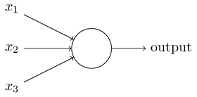
Figure 2 Perceptron
In the above example perceptron has three inputs, x1, x2 and x3. In general, it could have more or fewer inputs. This perceptron takes inputs and squashes it into specific range. the squashing is done by function, that is called activation function. The types of activation functions are sigmoid, tanh, relu, linear etc.

The architecture of neural network
Suppose we have a network:

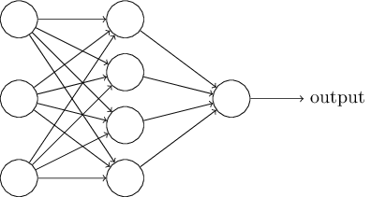
Figure 3 Basic architecture of neural network

The leftmost layer in above Figure 3 is called input layer, and the neurons within the layer are called input neurons. The rightmost or output layer contains the output neurons or as in this case a single output neuron. The middle layer is called a hidden layer, since the neurons in this layer are neither input not output. more than one hidden layer networks are called as multilayer perceptrons.

Basic of Convolutional Neural Networks
Convolutional neural networks are the widely used for image classification, recognition, object detection. There are different parts in CNN: convolution layer, Pooling layer, Full connected layer etc. The theory below were taken from [5]

Structure
The detailed view of CNN is take an image, pass it through a series of convolutional, nonlinear, pooling (down sampling) and full connected layer and outputs. The output is either a single class of probability of class that best describes the image.

First layer
The first layer in a CNN is always a Convolutional Layer. First thing to make sure you remember is what the input to this conv (I’ll be using that abbreviation a lot) layer is. Like we mentioned before, the input is a 32 x 32 x 3 array of pixel values. Now, the best way to explain a conv layer is to imagine a flashlight that is shining over the top left of the image. Let’s say that the light this flashlight shines covers a 5 x 5 area. And now, let’s imagine this flashlight sliding across all the areas of the input image. In machine learning terms, this flashlight is called a filter (or sometimes referred to as a neuron or a kernel) and the region that it is shining over is called the receptive field. Now this filter is also an array of numbers (the numbers are called weights or parameters). A very important note is that the depth of this filter has to be the same as the depth of the input (this makes sure that the math works out), so the dimensions of this filter is 5 x 5 x 3. Now, let’s take the first position the filter is in for example. It would be the top left corner. As the filter is sliding, or convolving, around the input image, it is multiplying the values in the filter with the original pixel values of the image (aka computing element wise multiplications). These multiplications are all summed up (mathematically speaking, this would be 75 multiplications in total). So now you have a single number. Remember, this number is just representative of when the filter is at the top left of the image. Now, we repeat this process for every location on the input volume. (Next step would be moving the filter to the right by 1 unit, then right again by 1, and so on). Every unique location on the input volume produces a number. After sliding the filter over all the locations, you will find out that what you’re left with is a 28 x 28 x 1 array of numbers, which we call an activation map or feature map. The reason you get a 28 x 28 array is that there are 784 different locations that a 5 x 5 filter can fit on a 32 x 32 input image. These 784 numbers are mapped to a 28 x 28 array. Let’s say now we use two 5 x 5 x 3 filters instead of one. Then our output volume would be 28 x 28 x 2. By using more filters, we are able to preserve the spatial dimensions better. Mathematically, this is what’s going on in a convolutional layer.

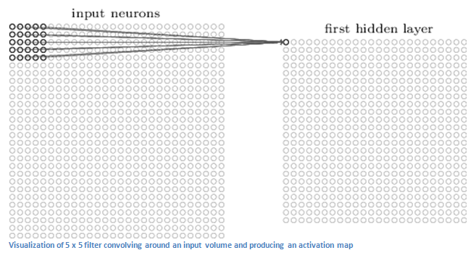
Figure 4 Activation Map

Going deeper through network
Now in a traditional convolutional neural network architecture, there are other layers that are interspersed between these conv layers. I’d strongly encourage those interested to read up on them and understand their function and effects, but in a general sense, they provide nonlinearities and preservation of dimension that help to improve the robustness of the network and control overfitting. A classic CNN architecture would look like this.

The last layer, however, is an important one and one that we will go into later on. Let’s just take a step back and review what we’ve learned so far. We talked about what the filters in the first conv layer are designed to detect. They detect low level features such as edges and curves. As one would imagine, in order to predict whether an image is a type of object, we need the network to be able to recognize higher level features such as hands or paws or ears. So let’s think about what the output of the network is after the first conv layer. It would be a 28 x 28 x 3 volume (assuming we use three 5 x 5 x 3 filters). When we go through another conv layer, the output of the first conv layer becomes the input of the 2nd conv layer. Now, this is a little bit harder to visualize. When we were talking about the first layer, the input was just the original image. However, when we’re talking about the 2nd conv layer, the input is the activation map(s) that result from the first layer. So each layer of the input is basically describing the locations in the original image for where certain low level features appear. Now when you apply a set of filters on top of that (pass it through the 2nd conv layer), the output will be activations that represent higher level features. Types of these features could be semicircles (combination of a curve and straight edge) or squares (combination of several straight edges). As you go through the network and go through more conv layers, you get activation maps that represent more and more complex features. By the end of the network, you may have some filters that activate when there is handwriting in the image, filters that activate when they see pink objects, etc.

Fully connected layer
Now that we can detect these high-level features, the icing on the cake is attaching a fully connected layer to the end of the network. This layer basically takes an input volume (whatever the output is of the conv or ReLU or pool layer preceding it) and outputs an N dimensional vector where N is the number of classes that the program has to choose from. For example, if you wanted a digit classification program, N would be 10 since there are 10 digits. Each number in this N dimensional vector represents the probability of a certain class. For example, if the resulting vector for a digit classification program is [0 .1 .1 .75 0 0 0 0 0 .05], then this represents a 10% probability that the image is a 1, a 10% probability that the image is a 2, a 75% probability that the image is a 3, and a 5% probability that the image is a 9 (Side note: There are other ways that you can represent the output, but I am just showing the SoftMax approach). The way this fully connected layer works is that it looks at the output of the previous layer (which as we remember should represent the activation maps of high level features) and determines which features most correlate to a particular class. For example, if the program is predicting that some image is a dog, it will have high values in the activation maps that represent high level features like a paw or 4 legs, etc. Similarly, if the program is predicting that some image is a bird, it will have high values in the activation maps that represent high level features like wings or a beak, etc. Basically, a FC layer looks at what high level features most strongly correlate to a particular class and has particular weights so that when you compute the products between the weights and the previous layer, you get the correct probabilities for the different classes.

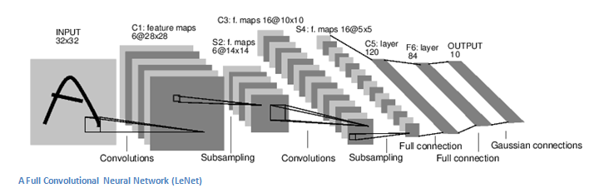
Figure 5 LeNet

Training
Now, this is the one aspect of neural networks that I purposely haven’t mentioned yet and it is probably the most important part. There may be a lot of questions you had while reading. How do the filters in the first conv layer know to look for edges and curves? How does the fully connected layer know what activation maps to look at? How do the filters in each layer know what values to have? The way the computer is able to adjust its filter values (or weights) is through a training process called backpropagation.

Before we get into backpropagation, we must first take a step back and talk about what a neural network needs in order to work. At the moment, we all were born; our minds were fresh. We didn’t know what a cat or dog or bird was. In a similar sort of way, before the CNN starts, the weights or filter values are randomized. The filters don’t know to look for edges and curves. The filters in the higher layers don’t know to look for paws and beaks. As we grew older however, our parents and teachers showed us different pictures and images and gave us a corresponding label. This idea of being given an image and a label is the training process that CNNs go through. Before getting too into it, let’s just say that we have a training set that has thousands of images of dogs, cats, and birds and each of the images has a label of what animal that picture is. Back to backprop.

So backpropagation can be separated into 4 distinct sections, the forward pass, the loss function, the backward pass, and the weight update. During the forward pass, you take a training image which as we remember is a 32 x 32 x 3 array of numbers and pass it through the whole network. On our first training example, since all of the weights or filter values were randomly initialized, the output will probably be something like [.1 .1 .1 .1 .1 .1 .1 .1 .1 .1], basically an output that doesn’t give preference to any number in particular. The network, with its current weights, isn’t able to look for those low-level features or thus isn’t able to make any reasonable conclusion about what the classification might be. This goes to the loss function part of backpropagation. Remember that what we are using right now is training data. This data has both an image and a label. Let’s say for example that the first training image inputted was a 3. The label for the image would be [0 0 0 1 0 0 0 0 0 0]. A loss function can be defined in many different ways but a common one is MSE (mean squared error), which is ½ times (actual - predicted) squared.

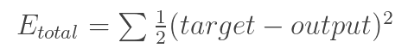
Let’s say the variable L is equal to that value. As you can imagine, the loss will be extremely high for the first couple of training images. Now, let’s just think about this intuitively. We want to get to a point where the predicted label (output of the ConvNet) is the same as the training label (This means that our network got its prediction right). In order to get there, we want to minimize the amount of loss we have. Visualizing this as just an optimization problem in calculus, we want to find out which inputs (weights in our case) most directly contributed to the loss (or error) of the network.

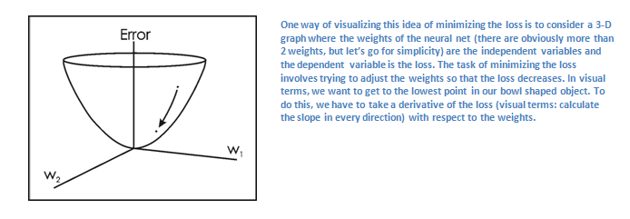
Figure 6 Minimizing Loss

his is the mathematical equivalent of a dL/dW where W are the weights at a particular layer. Now, what we want to do is perform a backward pass through the network, which is determining which weights contributed most to the loss and finding ways to adjust them so that the loss decreases. Once we compute this derivative, we then go to the last step which is the weight update. This is where we take all the weights of the filters and update them so that they change in the direction of the gradient.

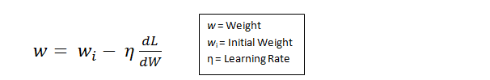

The learning rate is a parameter that is chosen by the programmer. A high learning rate means that bigger steps are taken in the weight updates and thus, it may take less time for the model to converge on an optimal set of weights. However, a learning rate that is too high could result in jumps that are too large and not precise enough to reach the optimal point.

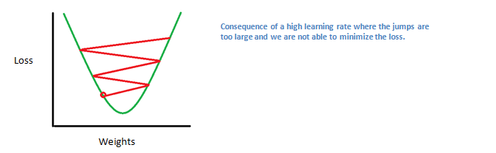
Figure 7 Optimization Problem

The process of forward pass, loss function, backward pass, and parameter update is generally called one epoch. The program will repeat this process for a fixed number of epochs for each set of training images (commonly called a batch). Once you finish the parameter update on the last training example, hopefully the network should be trained well enough so that the weights of the layers are tuned correctly.

Testing
Finally, to see whether or not our CNN works, we have a different set of images and labels (can’t double dip between training and test!) and pass the images through the CNN. We compare the outputs to the ground truth and see if our network works!

Proposed Work
This chapter presents the proposed work for the Melanoma skin detection. This section also presents the methodology of our proposed work and experimental results.

Architecture of Proposed Work

In our proposed system, we classified the skin cancer into two classes: malignant and benign. The block diagram of proposed work is shown in Figure 8.
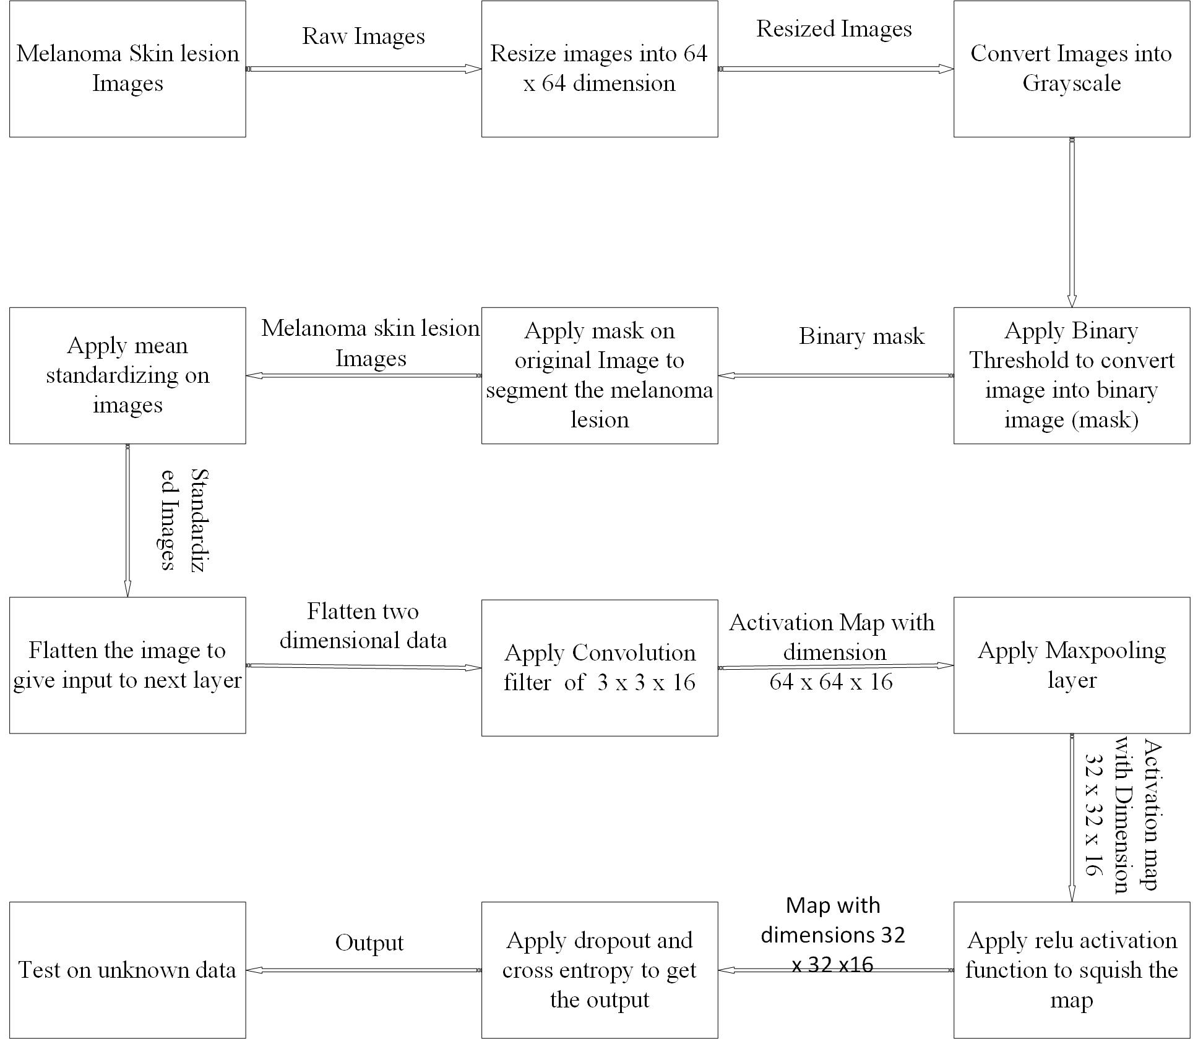
Figure 8 Block Diagram of Proposed work
    - Image Acquisition
We have collected images of melanoma skin cancer from the [6] which was the international challenge for Skin Lesion Analysis towards Melanoma Detection. There are total 2000 training, 600 testing and 150 Validation images.
    - Image Pre-processing
Since the images are raw images, it has different resolutions and size in training and testing data. the resolution of training images are 1022 x 767 pixels, while testing and validation images have 4288 x 2848 and 3024 x 2016 pixels respectively. The resolution is quite large. We could not make any heavy computation on these large size data. We did a heavy resizing to fit the data well for computation. We resized our image data to 64 x 64 for easy numerical computation. We used python library name PIL for load and resize the image data. Since the Images are high resolution, it is difficult to load whole data into memory. We load the data from directory, resize it and write it back to directory. It uses very less memory compared to other libraries, in case of batch processing.
After Image resizing, we did data augmentation. Data augmentation is used to improve the training data in case of limited training images. There are different ways we can do data augmentation like horizontal flipping, random crops and color jittering. We applied three augmentation techniques rotation, translation and flipping the images. The range of rotation and translation are (-20,20) and (-4,4) respectively. The Figure 5 shows the samples of augmented images.
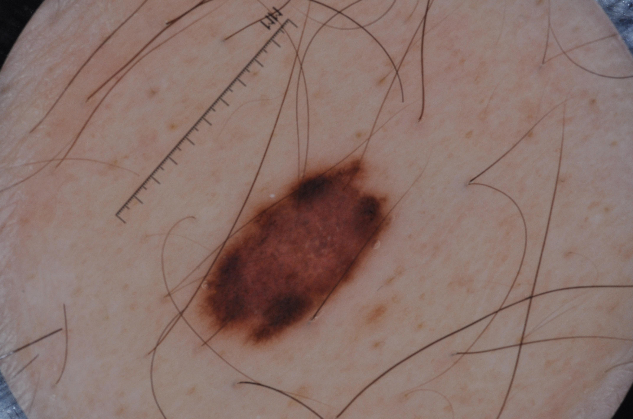 | 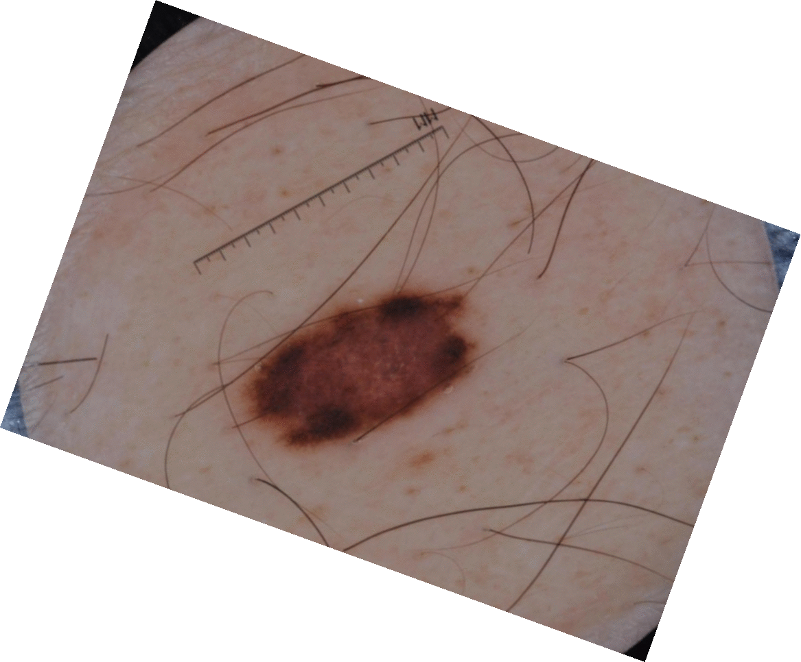 | 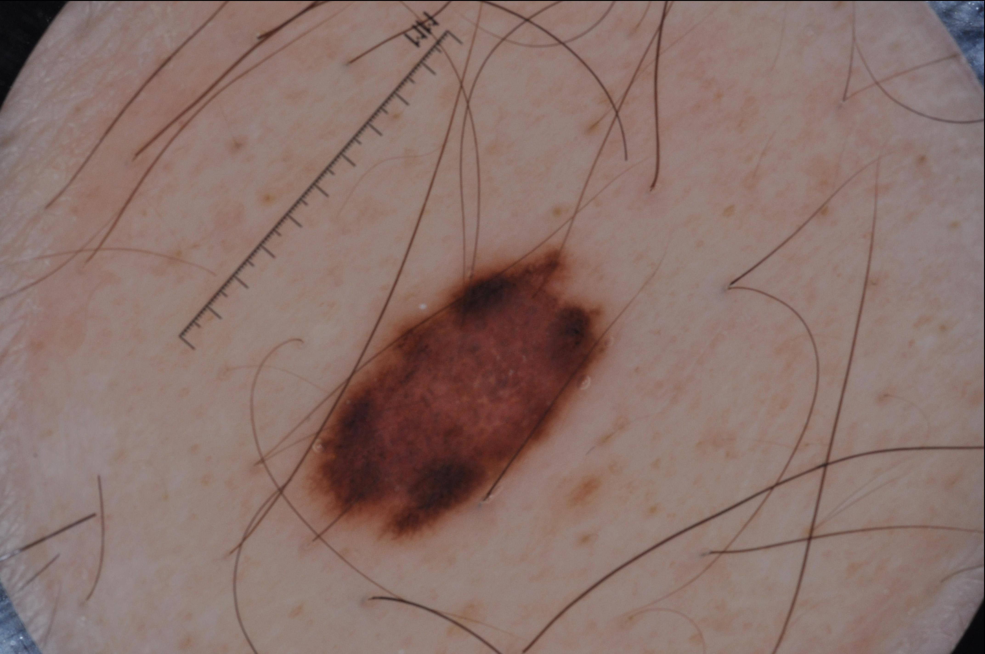 | 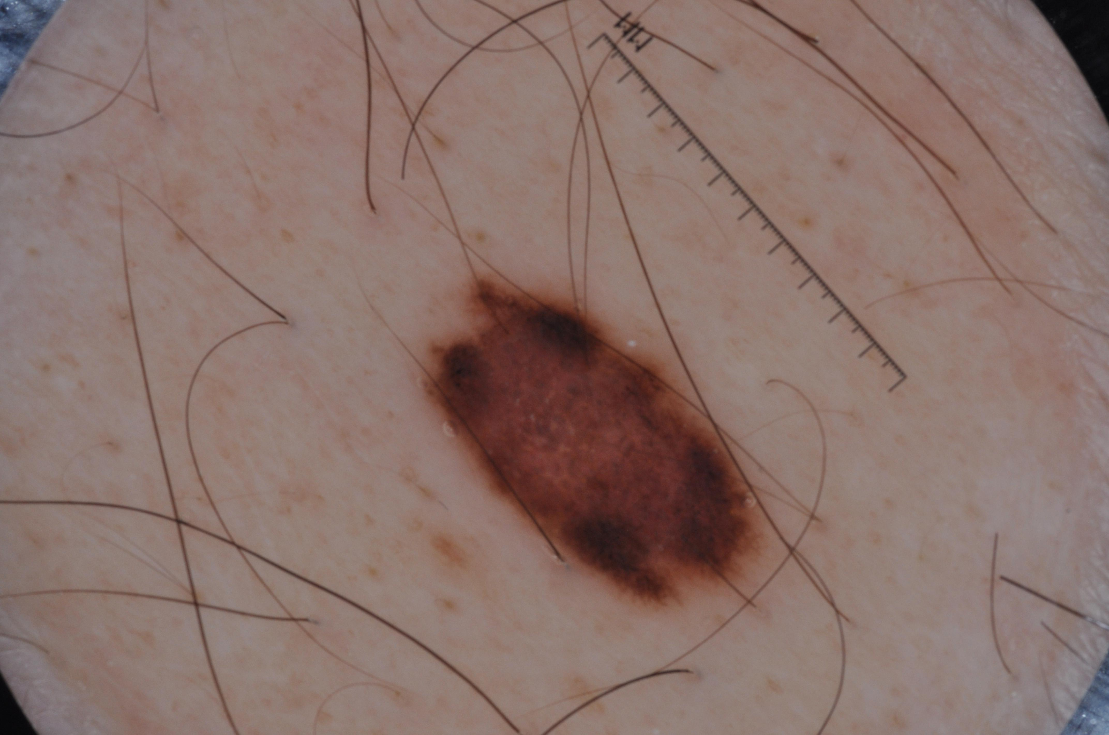
(a)Original Image | (b)Rotated Image | (c)Translated Image | (d)Flipped Image
Figure 9 Augmented Image samples
After Data augmentation, we do a center normalize the data. since the different input features have different scale so, we zero center the data then normalize it, so the min and max range is in the dimension between -1 and 1 respectively. We first subtract the images from the mean and then for divide it by the standard deviation to normalize it. The first step (subtract mean) was intended to zero center the data.
    - Model Building

The General Block Diagram of proposed work was shown in figure 6. After Pre-process the images, we fed the images into the convolutional neural network for training the network. The size of the input array is (2000,64,64,3). It is a four dimensional numpy array. The Architecture of the whole neural network is shown below:
Table 1 Full Simplified Network Architecture
Dimensions | Layer | No. of Neurons | Layer Description
[64 x 64 x 3] | Input | 12288
[64 x 64 x 32] | Conv1 | 32 | 3 x 3 filters at stride 2, pad 1
[32 x 32 x 32] | Max Pool1 |  | 3 x 3 filters at stride 2
[32 x 32 x 32] | Conv 2 | 32 | 3 x 3 filters at stride 2, pad 1
[16 x 16 x 32] | Max pool2 |  | 3 x 3 filters at stride 2
[16 x 16 x 32] | Conv 3 | 32 | 3 x 3 filters at stride 2, pad 1
[8 x 8 x 32] | Max pool3 |  | 3 x 3 filters at stride2
[2048] | Fully Connected1 | 2048
[2] | Fully Connected2 | 2 | Class scores

After each pooling layer, we applied relu function as activation function to squish the data into positive range. We applied Adam optimizer as optimization function. Softmax is used to find the probability at the final output layer. We took 0.75 probability as dropout keep probability. We were used cross entropy as a cost function. The learning rate is 1e-04. The Batch size is 100.

The Visualization of filters are show in below Figures:

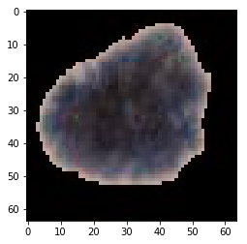
Figure 10 Input Image
Figure 10 shows the input image. The input image is passed to the neural network. The First layer was convolution layer with 3 x 3 filters and 32 dimensions. The below figure 11 shows the convolution filters. Since the first layer focuses on the low-level features such as edges. As shown in below figure the edges of the lesion was detected by first convolution layer.

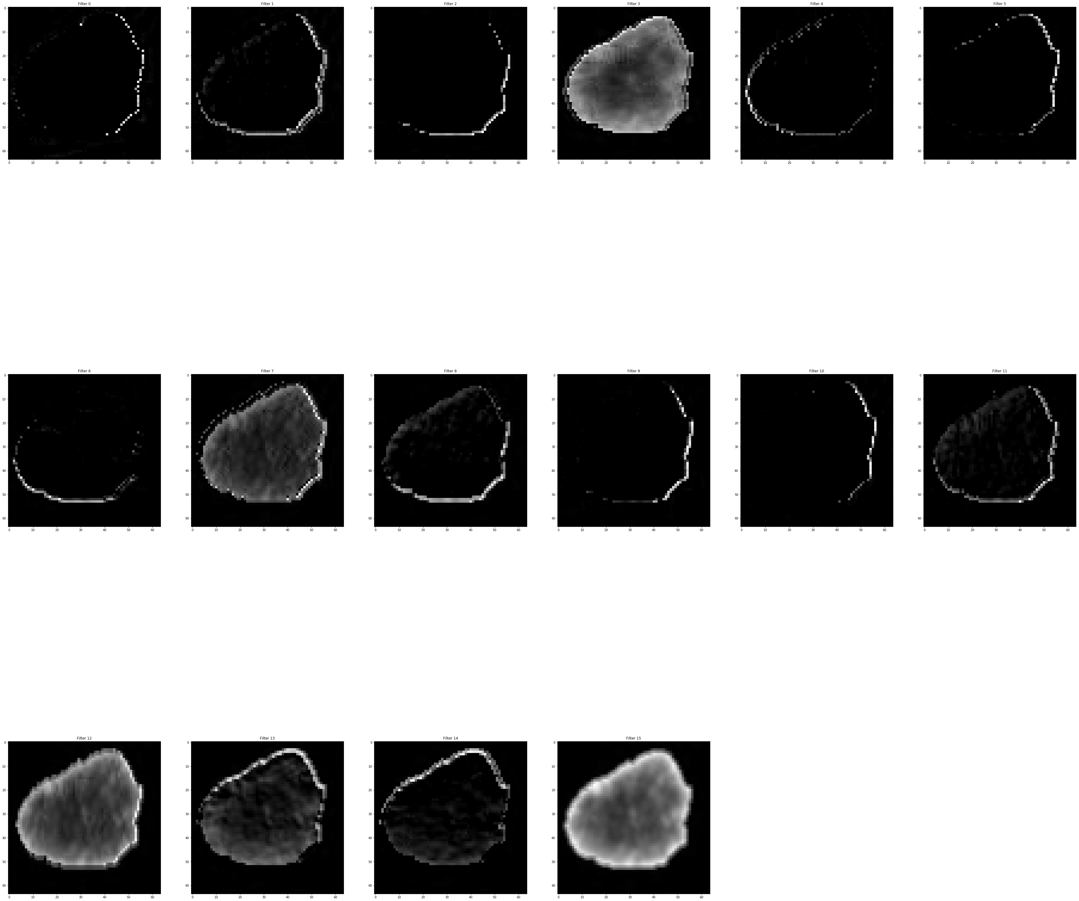
Figure 11 Conv 1
After First convolution, max pooling was applied. The filters were shown in the figure 12. Since pooling layer reduce the spatial dimensions the high frequency components of the image are popped out and move ahead for further computation.

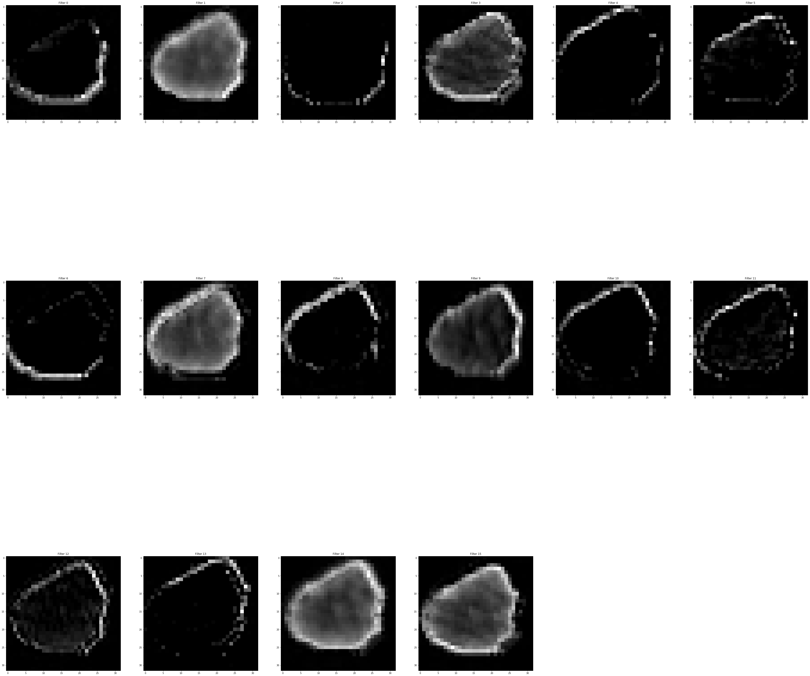
Figure 12 Max Pooling Layer1

Figure 13 Convolution layer 2

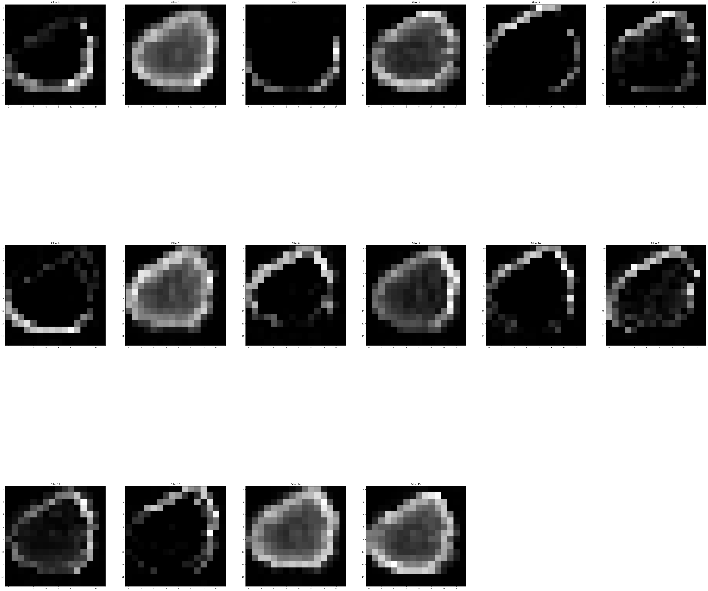
Figure 14 Max Pooling layer 2

Figure 13 shows next convolution layer and figure 14 was max pooling layer and it captures most of the content of the lesion. Figure 15 shows 3rd convolution layer which captures the high level features such as color histograms , texture features etc.
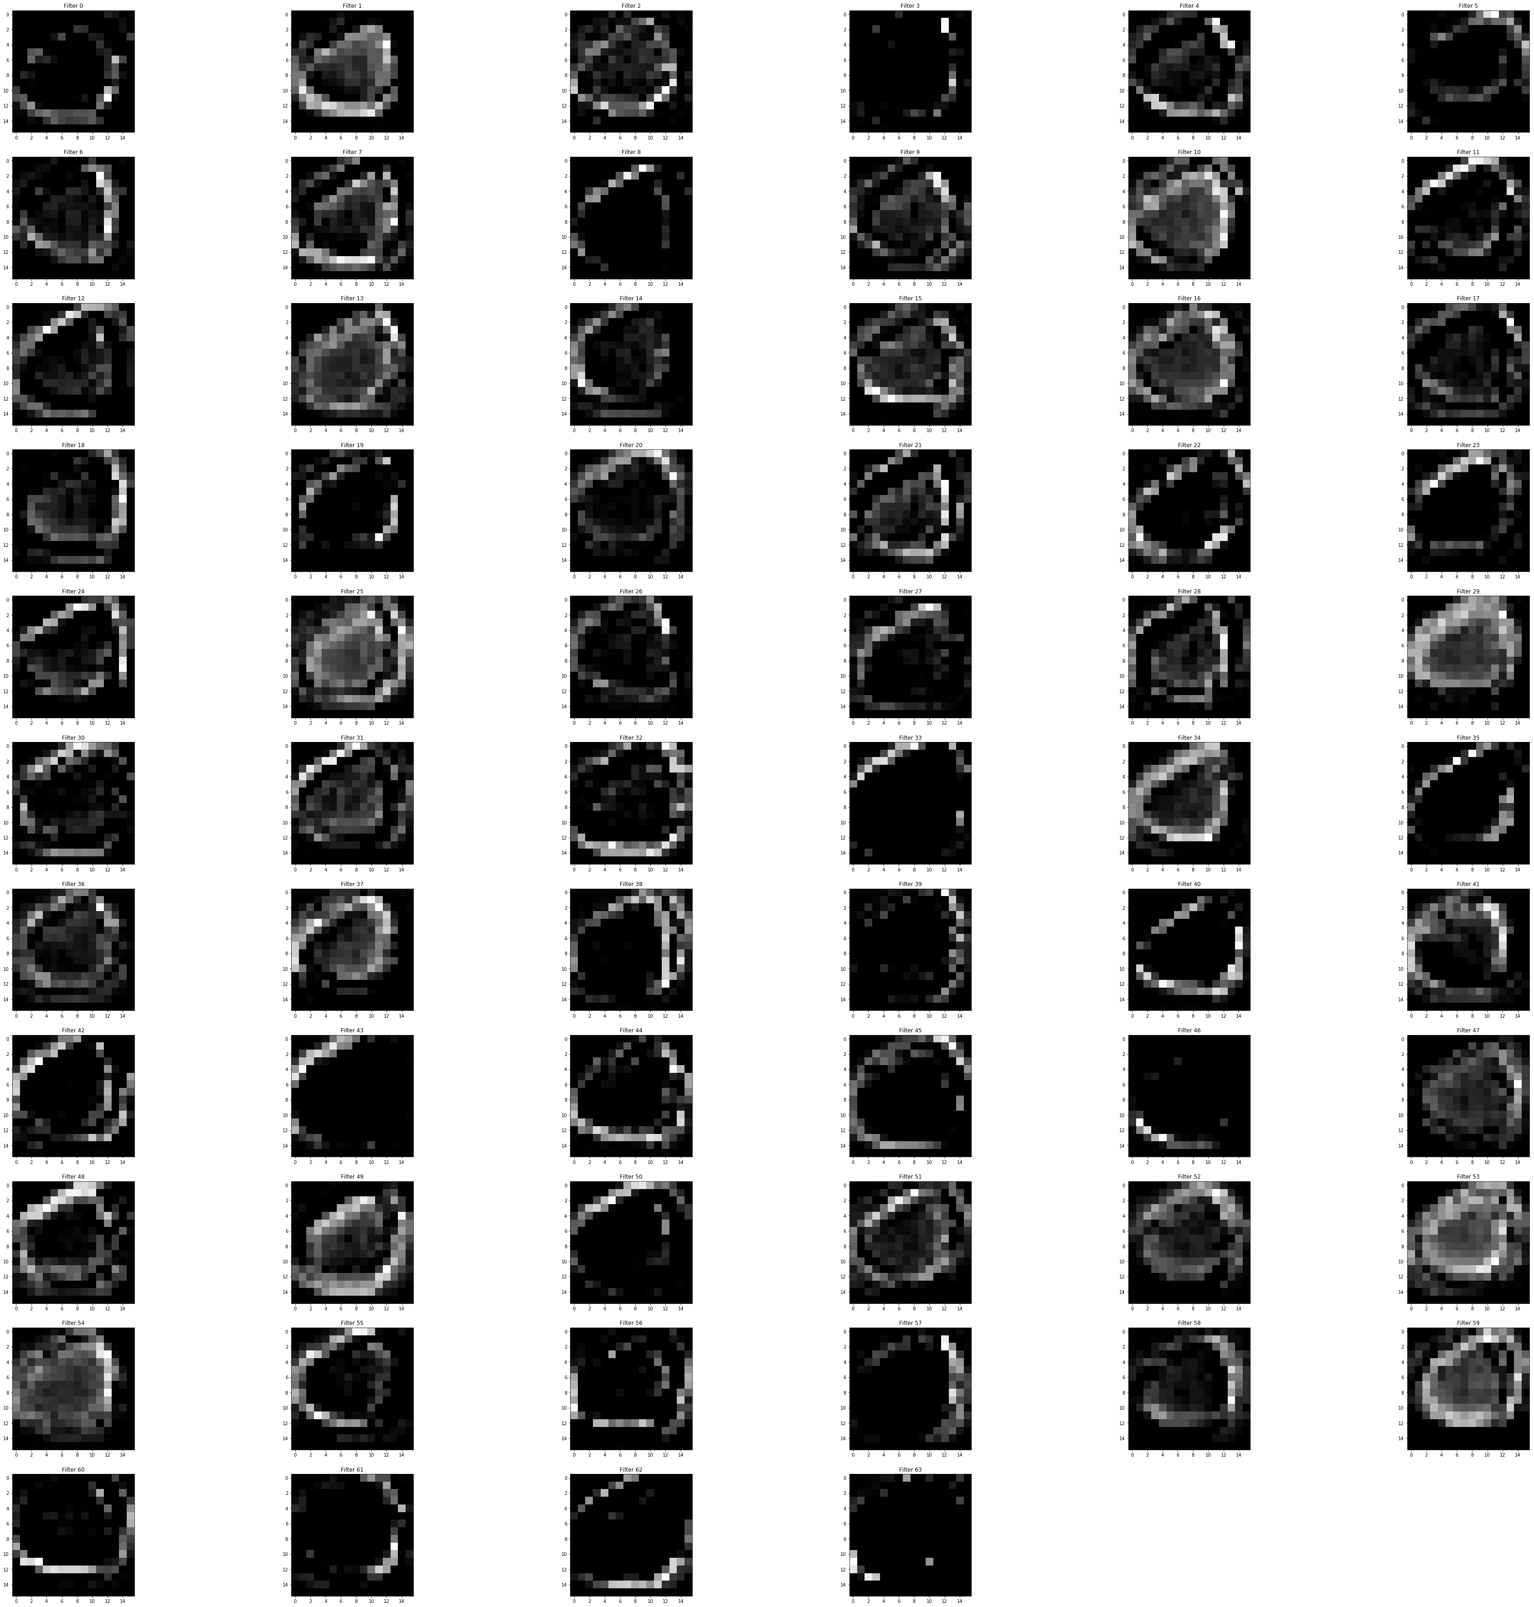
Figure 15 Convolutional layer 3

    - Model Evaluation
The model can be evaluated by the Different evaluation parameters: accuracy, Precision, recall, AUC and kappa score.
Statistics of the dataset is shown in table 2. The Results of proposed methods on test data is shown in table 3.
Table 2 No. of Samples
 | Malignant | Benign
Training Data | 374 | 1626
Testing | 117 | 483
Validation | 30 | 120

The accuracy on training data is 87 % and on testing data is 82 %. Precision is 0.7435 and 0.0.200. the AUC we got is 0.5125.

References
- What Is Melanoma Skin Cancer?", Cancer.org, 2017. [Online]. Available: https://www.cancer.org/cancer/melanoma-skin-cancer/about/what-is-melanoma.html. [Accessed: 14- May- 2017].
[2] "Covalic", Challenge2017.isic-archive.com, 2017. [Online]. Available: http://challenge2017.isic-archive.com. [Accessed: 14- May- 2017].
[3]"American Cancer Society. Cancer Facts & Figures", 2017.
[4] M. Nielsen, "Neural Networks and Deep Learning", Neuralnetworksanddeeplearning.com, 2017. [Online]. Available: http://neuralnetworksanddeeplearning.com/. [Accessed: 14- May- 2017].
[5] A. Deshpande, "A Beginner's Guide To Understanding Convolutional Neural Networks", Adeshpande3.github.io, 2017. [Online]. Available: https://adeshpande3.github.io/adeshpande3.github.io/A-Beginner's-Guide-To-Understanding-Convolutional-Neural-Networks/. [Accessed: 14- May- 2017].

Research Publications

Curriculum Vitae

